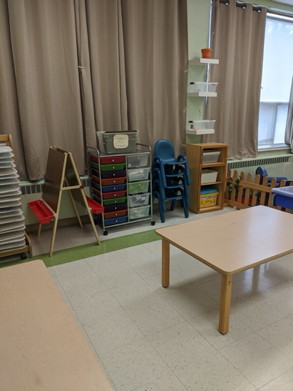
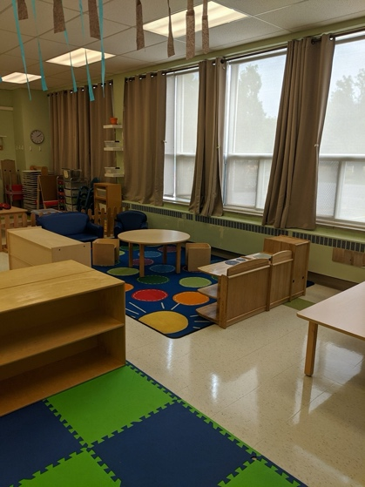
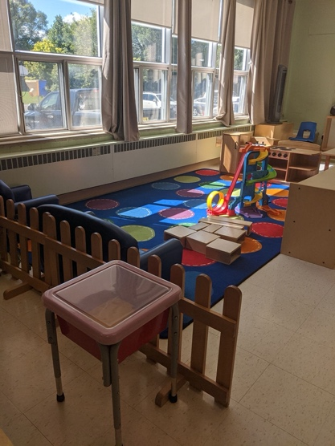
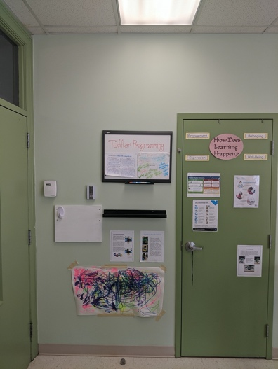
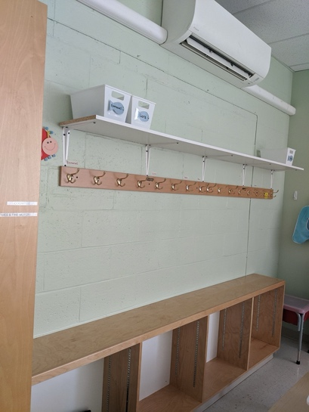
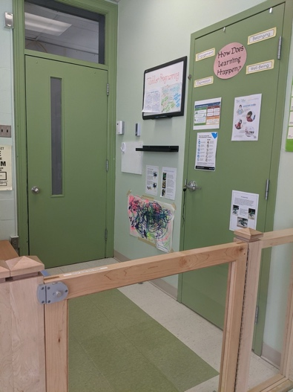
This is our main learning and play space where gross motor, dramatic play, block building and cognitive opportunities take place. Furniture is arranged to encourage social interactions and communication with peers. Furniture is set on the children’s level where they can access a wide variety of materials. The use of materials and loose parts in every area of the space is encouraged to extend the children’s play. A fluid room provides a sense of belonging and engagement.
As you walk into the program room, a wall with hooks is used to store the children’s belongings, such as coats, sweaters, hats, shoes, etc. Each hook and basket are labelled with each child’s name. Residing beside the hooks are two tables encompassing our art and eating space. This is where sensory and art experiences are encouraged, and varieties of materials provided. For mealtimes, the tables are evenly spaced apart to allow for safe distancing while still engaging in conversation with each other.
Welcome to the Toddler Program! As you walk in, the front entrance shows the “How Does Learning Happen” framework displayed with documentation. Artwork and pictures of the children’s learning are displayed in this space as well. It allows the children to see themselves and feel pride of their accomplishments. An in-house laundry room is provided and utilized daily. An enclosed gate separates the front entrance from the room to ensure safety while providing an additional space for dressing and transitions.

