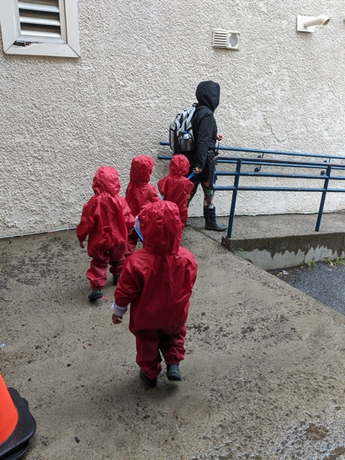
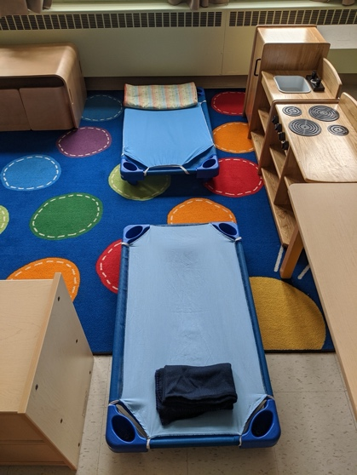
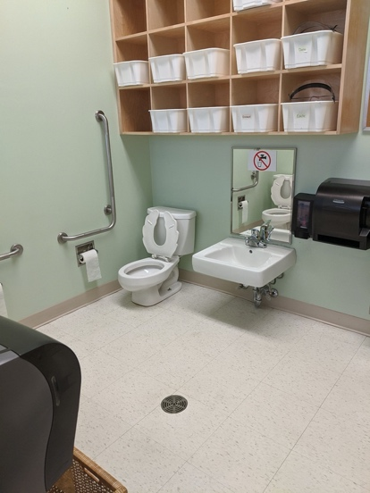
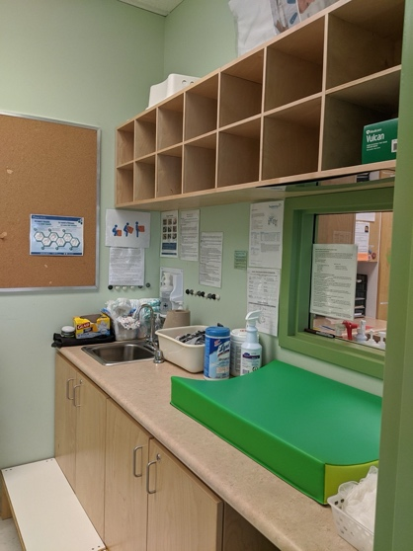
As per new Ministry of Education guidelines, children’s cots are situated toe to toe, allowing a safe distance between faces. The sheets /blankets are changed, and cots are disinfected daily. A two-hour rest time takes place 12:00pm-2:00pm.

During inclement weather, our red muddy buddy suits are used for outdoor play. This facilitates learning in outdoor environments as much as possible. The children enjoy exploring puddles and getting dirty!
In the classroom, is a designated bathroom area where toilets, sinks and other needs are smaller sized allowing the children to develop their self-help skills and independence. For some of the younger children, a change table is utilized. Each child has a cubby for their extra clothes and diapers, which is labelled. Many wonderful opportunities for expanding the children’s skill happens during our bathroom routines. Sitting/standing at the toilet is encouraged but not expected.

